The ODD Campaign As of 23 Feb 2021

A Brief History of the East of Otley Development

1. The Relief Road
The origins of the EoO development can be traced back to a public consultation during 1978 on three alternative routes for a proposed new road from the Leeds Road roundabout heading east towards Pool. The selected “red” route joined the A659 on the bend south of Knotford Nook.

However, in 1995 the proposed route was altered to join the A659 by Stephen Smiths. Thus, the current alignment of the EoO “relief road” was broadly established - together with the possibility of building houses to fund the new road.

2. The East of Otley “Allocation”
Next step was to push the green belt, which previously ran along the eastern edge of Otley, out to the east to encompass the anticipated relief road. The stated aim being to “create a definitive eastern boundary to Otley”. However, result was the creation of a no longer protected “EoO development site” lying within the anticipated relief road.

The EoO site was formally “allocated for development” in the new Leeds Unitary Development Plan (UDP) which was adopted in 2001. The identified 30ha site (which excluded Ings Tip) was allocated for development with 20ha of housing and 5ha of employment land.

By 2003 EoO was scheduled for “phase 1” release for up to 850 houses!

In 2005 the appointment of an Independent Inspector to review the UDP, enabled a sustained campaign to be mounted by residents against the EoO allocation. The Inspector, who was not empowered to delete the EoO allocation, was persuaded to delay its release until “phase 3” and imposed a raft of additional conditions on its development.

3. The Leeds UDP
In 2006 the national planning system was revised, requiring that the UDP be replaced by the still current Local Development Framework (LDF).

At the start of what proved to be a lengthy transition period, a long list of existing Leeds UDP policies and development site allocations were “saved”. Meaning that they were rolled over into the Leeds LDF without further consideration. EoO was one of the “saved” allocations.

The LDF comprises two major parts, the Core Strategy (CS) and the Site Allocations Plan (SAP), together with many other smaller parts. The CS contains the “planning policies” and also sets an agreed overall “housing target” for Leeds. The role of the SAP is to allocate and release housing sites to meet this target.

It was a long time until the Leeds LDF was completed, the SAP was not formally “adopted” until 2019. Meanwhile, the 30ha EoO site was formally designed as SAP mixed-development site MX1-26 (550 houses, 5ha employment land and a new school). It has now been “released for development” for some years.

4. Behind the Scenes
Complex negotiations, over an extended period, between the many original landowners (who include Leeds City Council) and the developers have resulted in the whole site (together with the adjacent fields to the east), coming under the control of the developers. This through land purchase or options to purchase.

LCC produced a detailed Development Brief for EoO dated February 2020. This key document was not seen by members of the public until February 2021.

There have clearly been ongoing negotiations between the developers and LCC regarding how:
- The site should be developed, and
- The design and construction of the relief road should be funded (minutes of the City Plans Panel).
It seems likely that these negotiations only succeed because LCC (who are taking the lead regarding the relief road) secured £6.3m of Housing Infrastructure Funding towards the much greater costs of the relief road.

5. The Emergence of “Otley East”
Otley East is the name given to their proposed development by the Otley East Consortium. The latter comprises the two lead developers (Persimmon and Lovell Homes) plus Leeds City Council.

The Otley East Consortium launched a website-based public consultation on 15 January 2021. This “pre-planning application consultation” closed on the 29 January 2021 and embraced a site considerably larger than the site MX1-26 allocation.

The Otley East Consortium is understood to have stated that a hybrid planning application will be submitted on 26 February 2021. This will seek:
- Full detailed planning permission for the relief road, the first phase of residential development, the relocation of the sports pitches, landscaping and open space, and
- Outline planning permission for the balance of the site.

Construction on the relief road is programmed to commence in Winter 2021 and is expected to take approximately 24 months.

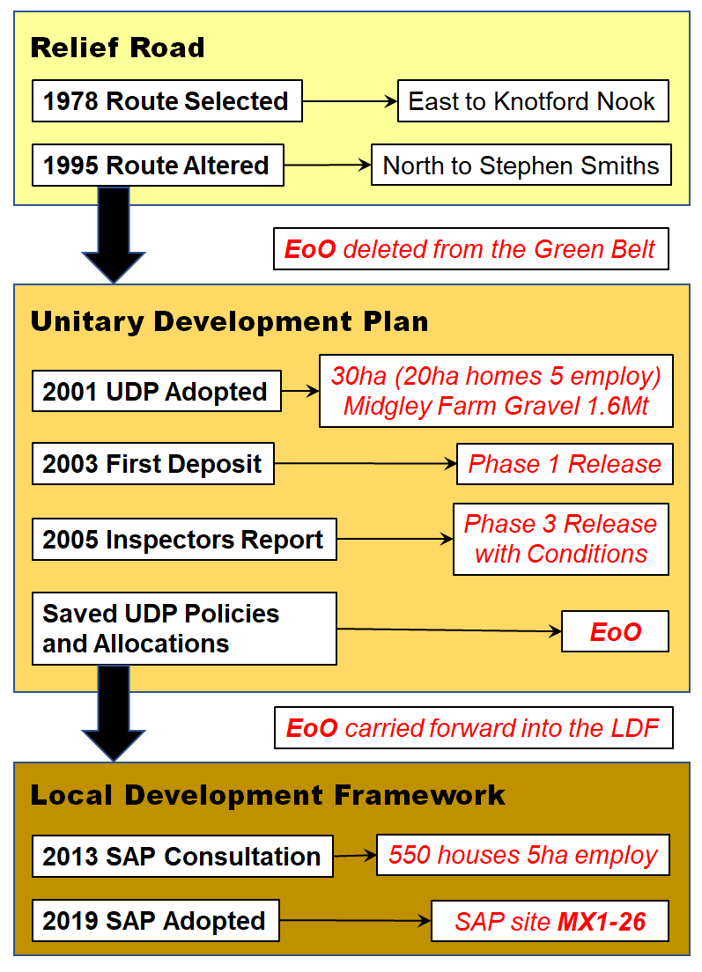 | A simplified Planning History  of SAP Site MX1-26 (East of Otley) up to 2020

